Manitowoc County Youth Sports, Inc.
Minutes from March 22nd, 2026 Officers, Directors & Commissioners Meeting
Submitted by Shannon Kish, Secretary Treasurer

The March 22, 2026 meeting was held at OverTime in Valders.

President Glaeser called the meeting to order at 5:00 PM.

Officers, Directors, and Commissioners present: Steve Barta, Ray Berres, Kraig Binversie, Kevin Bonde, Adam Christiansen, Heather Garceau, Lee Glaeser, Shannon Kish, Allen Kliment, Todd Meyer and Adam Neuser.

Craig Sesing from New Holstein joined us as he is possibly interested in joining the Senior Fast Pitch MCYS league. He was told of the May 2nd deadline and will let us know.

Motion to approve the February 15, 2026 meeting minutes was made by Christiansen. Seconded by Barta. Motion carried.

Motion to approve the Treasurer’s Report as of March 1, 2026 was made by Barta. Seconded by Christiansen. Motion carried.

Glaeser spoke on the umpire clinic that will be held next week Saturday. Kish noted that as of the meeting, 18 people have RSVP’d. Meyer and Neuser will be there to help as well.

Rule changes for 2026 were discussed as follows:

Pony:
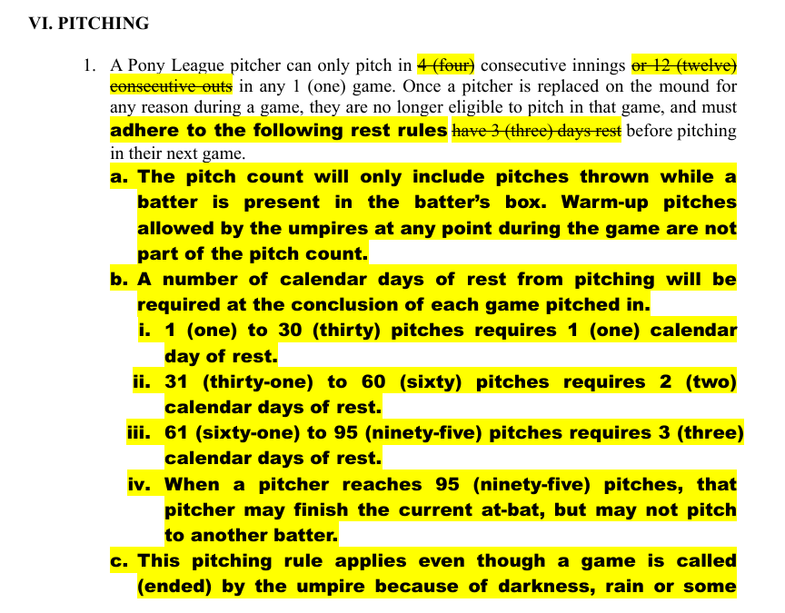
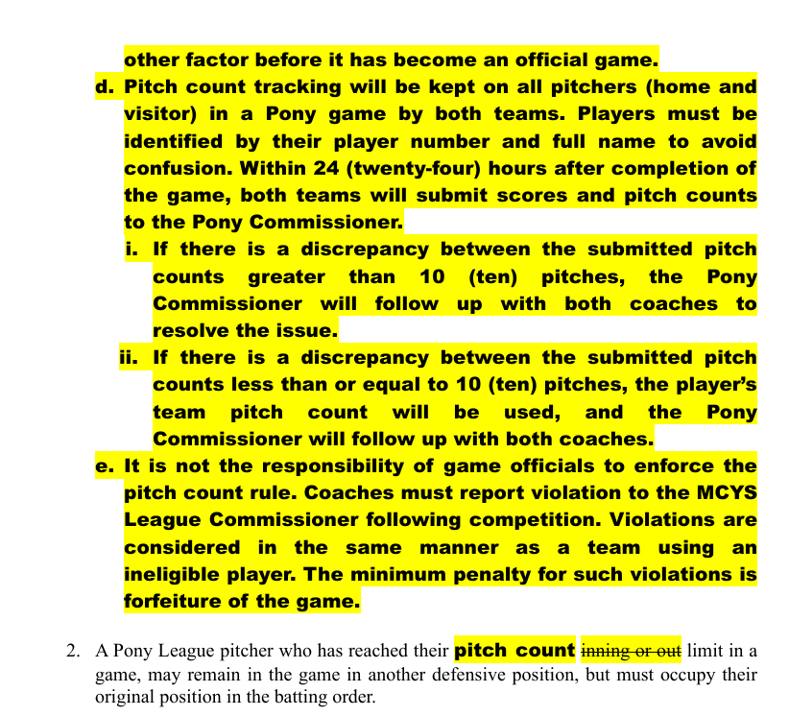
Motion made by Binversie to approve as presented. Seconded by Neuser. Barta, Christiansen, Kish, Meyer and Garceau were opposed. Motion denied. Binversie will present wording next meeting to clean up the rest regulations in the original rule but keep everything else as it was in 2025.

Pee Wee:
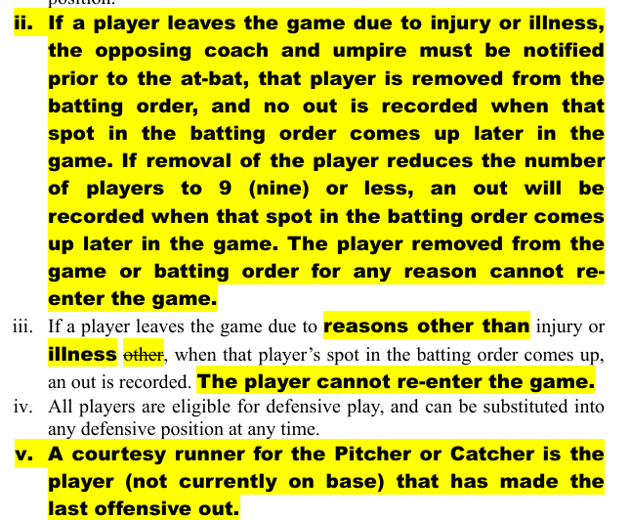

Motion made by Christiansen to approve as presented. Seconded by Kliment. Motion carried.

Grade School Modified:
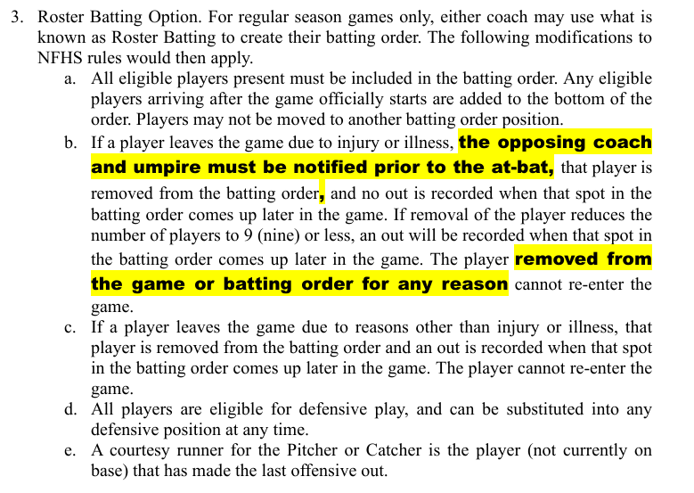

Motion made by Barta to approve as presented. Seconded by Kliment. Motion carried.

JFP:
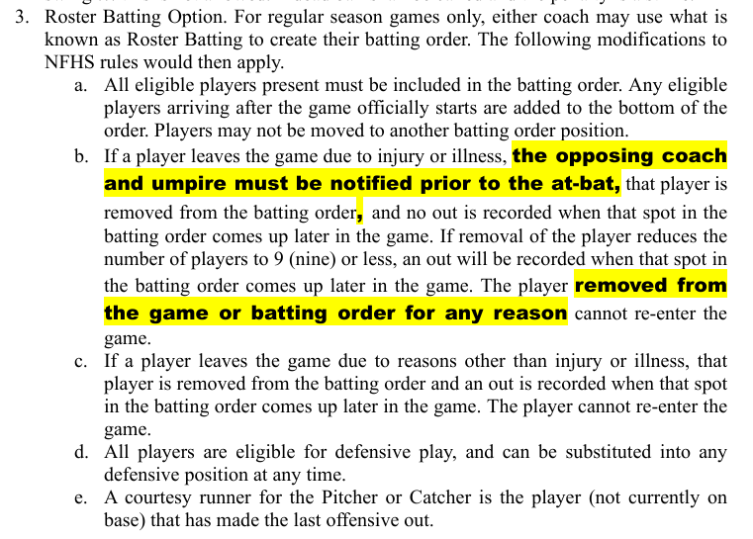

Motion made by Barta to approve as presented. Seconded by Neuser. Motion carried.
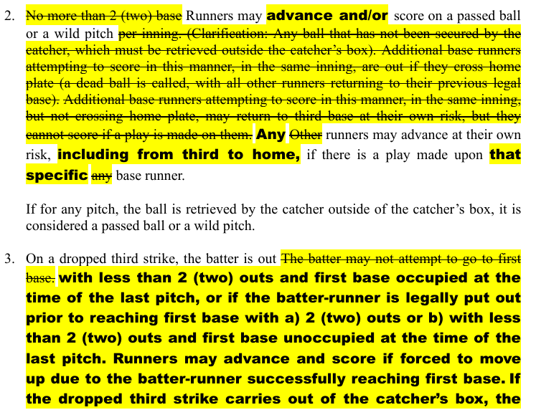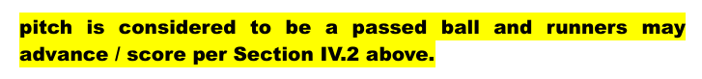

Motion made by Christiansen to approve as presented. Seconded by Barta. Motion carried.

Machine Pitch:
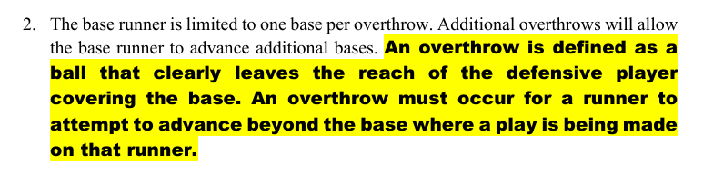

Motion made by Binversie to approve as presented. Seconded by Meyer. Motion carried.
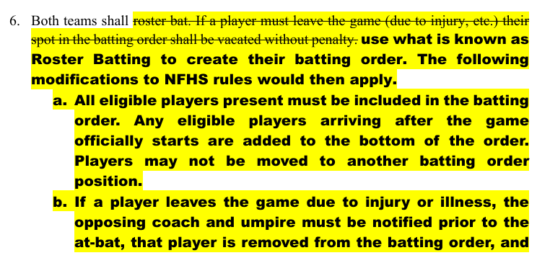
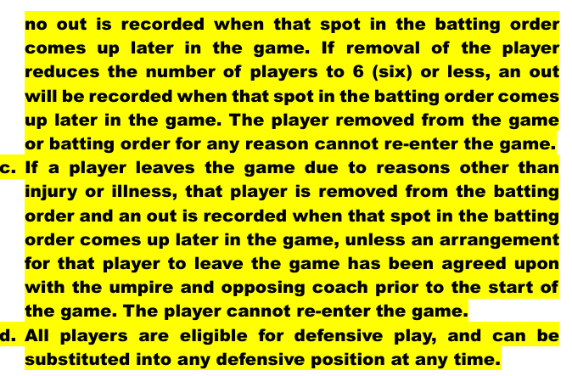
Motion to approve as presented made by Barta. Seconded by Garceau. Motion carried.

Bonde spoke on permission slips/rosters as it was noted there were a few that were not turned in to the secretary for 2025. Reminded commissioners to make sure they are all printed and turned in as they are kept for 3 years.

Bonde spoke on the 2026 awards increase. Discussion was held and Barta made a motion to no longer give individual trophies or medals for division winners, only team plaques. Championship weekend awards will remain the same. Kliment seconded. Meyer was opposed. Motion carried.

Bonde spoke on research he did on the 2025 MCYS Modified, JFP, Pee Wee and Pony teams. A print out was provided with breakdowns of age groups by community for each level.

Calendar for 2026 was approved. It was noted that the Spring Meeting will also have discussion about possibly changing age groups to grades for 2027. Kish will notify community contacts and encourage attendance so that there can be discussion.

Christiansen spoke on 2 additional requests he received for Peanut rule changes prior to the February 1st deadline. One was regarding machine pitch and/or throwing from the knees and the other being a shorter season with more games scheduled. No changes will be made at this time.

Motion to adjourn made by Barta. Seconded by Christiansen. Motion carried.

