Manitowoc County Youth Sports, Inc.
Minutes from February 15th, 2026 Officers, Directors & Commissioners Meeting
Submitted by Shannon Kish, Secretary Treasurer

The February 16th, 2025 meeting was held at OverTime in Valders.

President Glaeser called the meeting to order at 5:00 PM.

Officers, Directors, and Commissioners present: Steve Barta, Ray Berres, Kraig Binversie, Kevin Bonde, Adam Christiansen, Heather Garceau, Lee Glaeser, Jason Keller, Shannon Kish, Allen Kliment, Steve Kuenstler, Todd Meyer and Adam Neuser.

Motion to approve the September 10, 2025 Wrap Up Meeting minutes was made by Christiansen and seconded by Barta. Motion carried.

Motion to approve the Treasurer’s Report as of February 1, 2026 was made by Barta and seconded by Kliment. Motion carried.

Zack Lensmire from Howards Grove was invited to discuss the Colt league however was unable to attend again but does still have interest in joining.

Zack Sand and Andrew Deehr attended our meeting to talk about possibly combining MCYS with MIBA (Calumet County). They only have boys leagues from grades K-8 and discussed that the biggest difference between the 2 leagues is how we each distinguish levels. Currently they have Rookies (K-2nd) Traveling (3rd-4th), Little (5th-6th) and Pony (7th -8th). They spoke on how the smaller age groups allow kids more playing time and the ability to play and grow at more positions. Their season starts 5/18 and they play one game a week until school is out, then it is 2 games a week (M&W or Tu&Th depending on the league). Games start at 5:30 and do have a time limit. Their end of year tournament has a gold and silver bracket which is seeded by the percentage of wins during the 6 week season. They find this works well as you don’t have the top teams playing the bottom teams right away. They use teamlinkt to streamline standings, forms etc. Their website is www.calumetbaseballleague.com.

The discussion lasted about an hour and we as a board decided it was certainly something to consider however we need to talk to our communities. We realize that a May 18th start date would make it nearly impossible to combine this year but if its what the communities want, we would work to make it happen for next year.

Glaeser spoke on the Umpire Clinic scheduled for March 28th from 10-2pm. Kish noted that there are currently 6 people that have signed up.

Kish noted the amount spent per team in 2025 increased to $163.78, up from $152.66 in 2024. Our current entry fee is $130.00. Thanks to a large donation from the West Foundation we haven’t needed to increase team fees to match at this time.

Discussion was held regarding awards prices increasing 25% this year. Several options were brought up but no decision was made. It was decided to wait to make a motion until our March meeting.

Rule changes for 2025 were discussed as follows:

JFP:
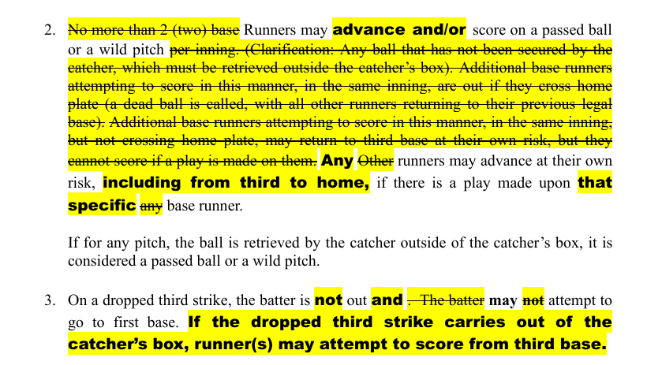
Motion made by Kuenstler to approve as presented. Seconded by Kliment. Binversie and Meyer were opposed. Motion carried.

Machine Pitch:

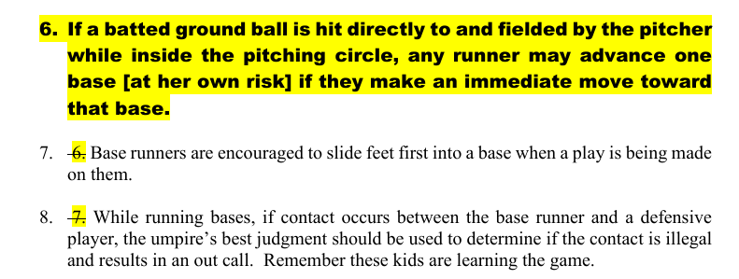
Motion made by Keller to approve as presented. Seconded by Barta. Motion carried.

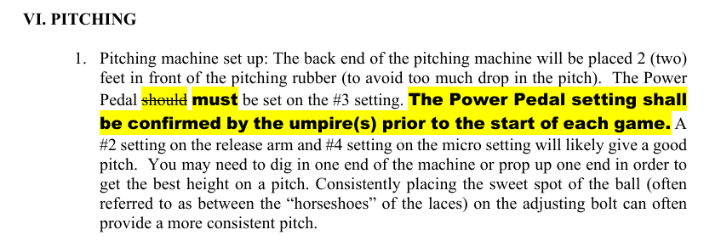
Motion made by Keller to approve as presented. Seconded by Christiansen. Motion carried.
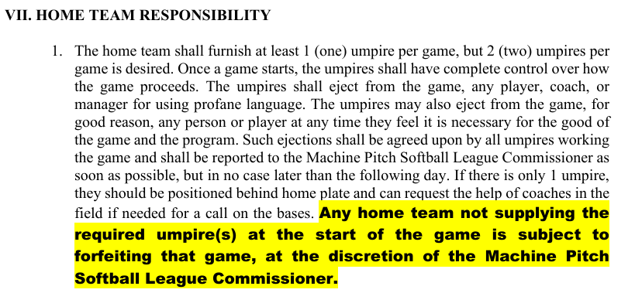
Motion by Christiansen to approve as presented. Seconded by Keller. Motion carried.

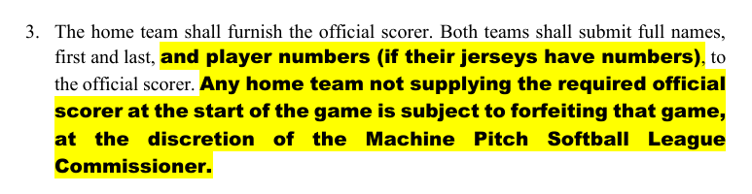
Motion made by Christiansen to approve as presented. Seconded by Keller. Motion carried.

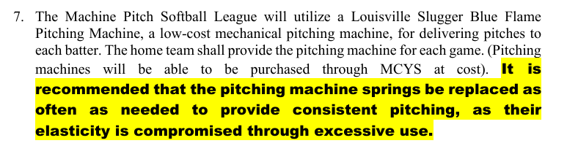
Motion made by Barta to approve as presented. Seconded by Keller. Motion carried.

PeeWee:

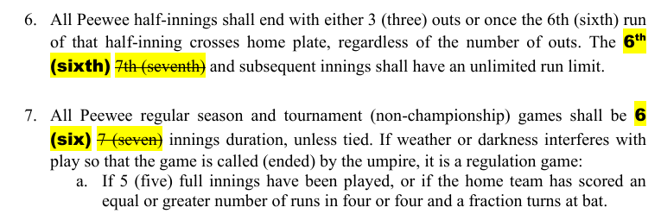
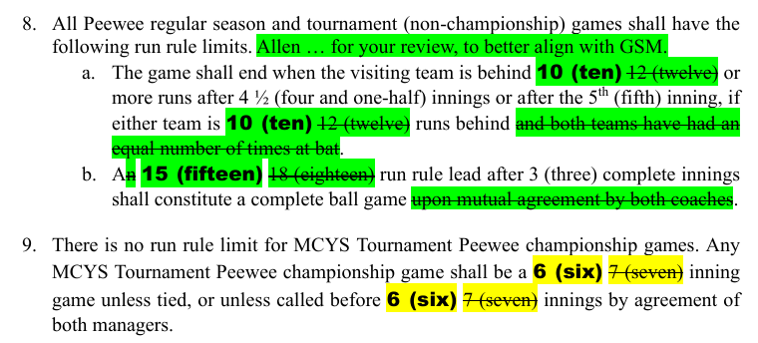
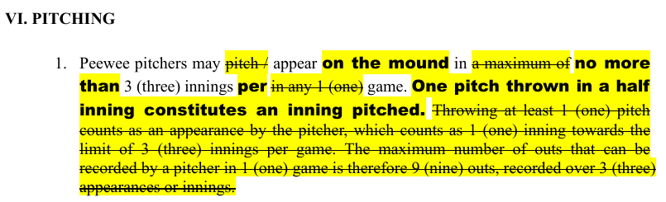
Motion made by Garceau to approve as presented. Seconded by Berres. Barta and Christiansen were opposed. Motion carried.

Peanut:

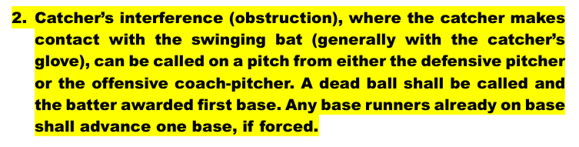
Motion made by Barta to approve as presented. Seconded by Binversie. Motion carried.

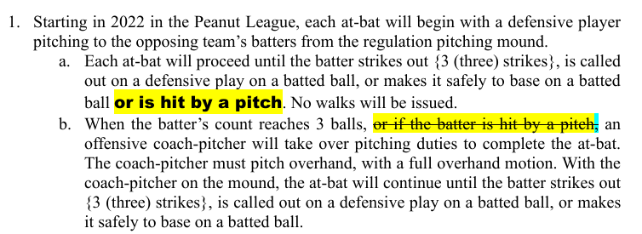
Motion made by Garceau to not approve rule as presented. Seconded by Meyer. Motion carried.

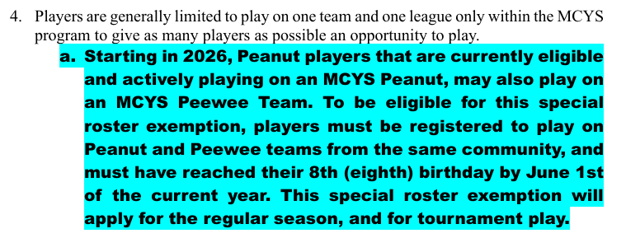
Motion made by Barta to approve as presented. Seconded by Meyer. Christiansen opposed. Kish did not vote due to conflict of interest. Motion carried.

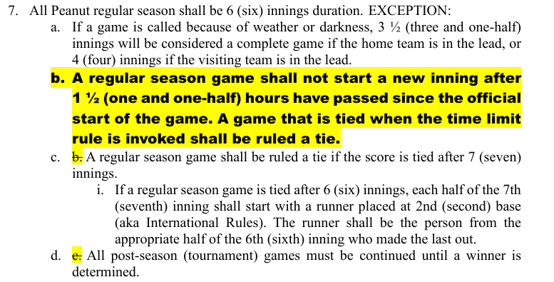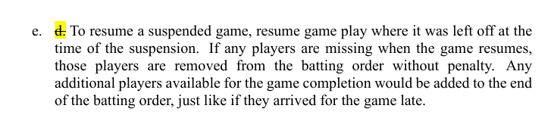
Motion to deny as presented made by Garceau. Seconded by Christiansen. Motion carried.

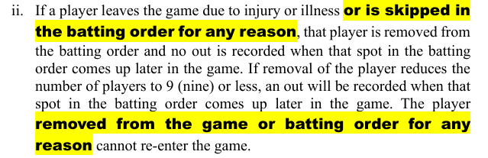
Motion made by Barta to approve with minor wording adjustments made by Christiansen. Seconded by Garceau. Motion carried.

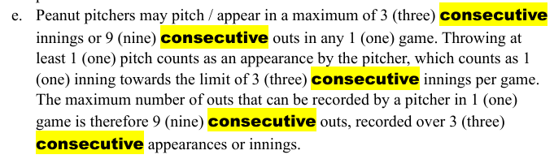
Motion to approve as presented made by Barta. Seconded by Christiansen. Motion denied with all other voting members opposed. Bonde abstained.

Motion to approve the 2026 Permission Form, Team Entry Form and Team Roster forms with an adjustment to the umpire clinic times on the permission form made by Neuser. Seconded by Keller. Motion carried. Bonde will make adjustments. Kish will email to community contacts.

Next meeting will be March 15th. We would like community contacts and coaches to attend the April meeting to discuss possible changes for next year based on conversation with Zack.

Motion to adjourn made by Barta. Seconded by Binversie. Motion carried.
.

